|  |
| --- |
| Course Code: **CCCN 221**  Course Name: Computer Architecture  **HW # 2** |

Convert the following below High Level Languages to Assembly Language (MIPS)



Assume that, **f**, **g**, **h**, **i**, **j, k** are in **$s0**, **$s1**, **$s2**, **$s3**, **$s4, $s5**, respectively, and base address for arrays **A & B** are in **$s6** and  **$s7**.



**Code 1:**



f = -g - A[4]

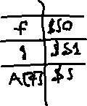

**Code 2:**

B[8] = A[i-j];

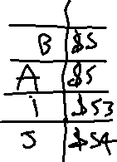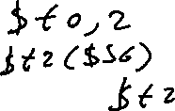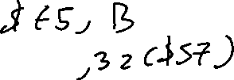

**Code 3:**

if (i==j)

f = g+h;  
else



f = g-h;

